Tuesday 25th January 2021

**-To divide decimals by integers**

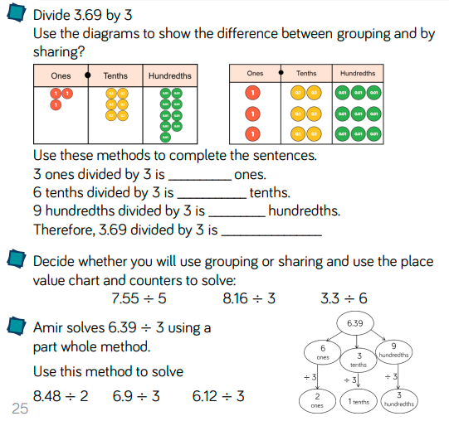**Practice**

**Reasoning**

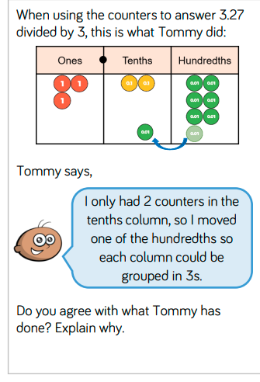

**Problem Solving**

