[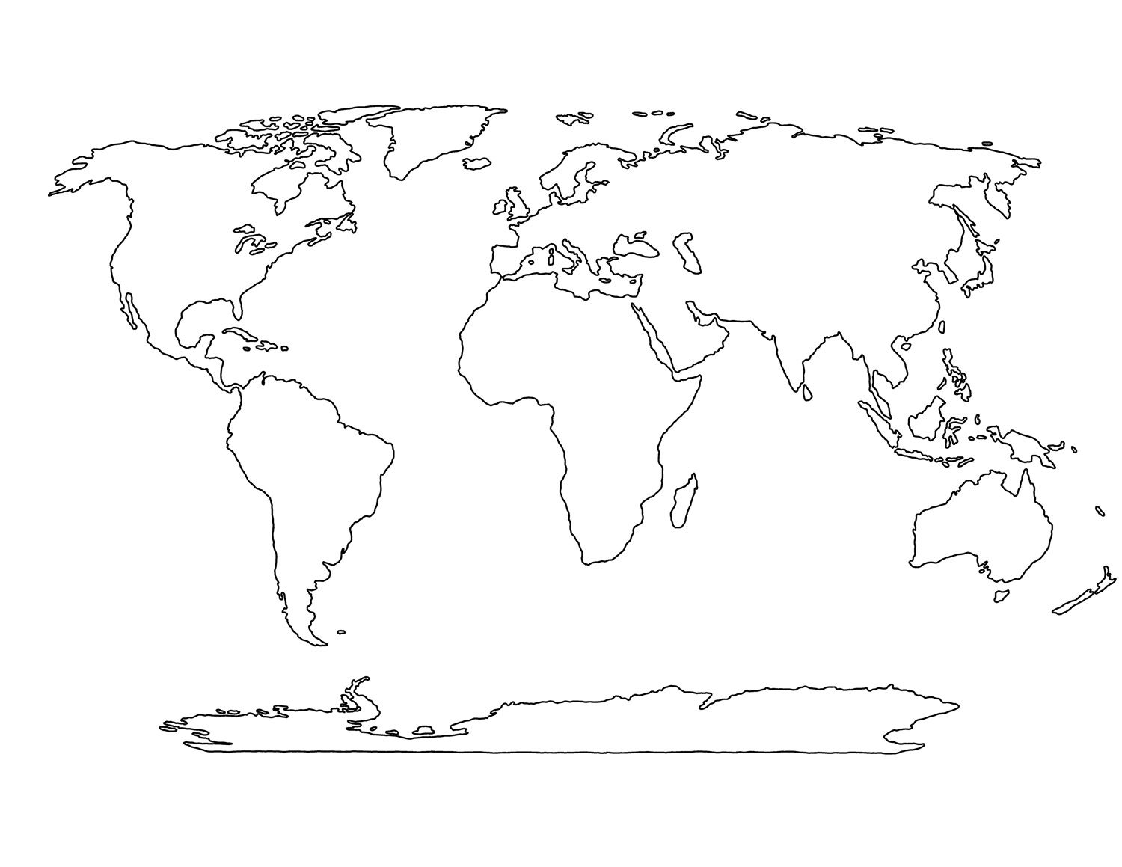](https://www.google.co.uk/url?sa=i&rct=j&q=&esrc=s&source=images&cd=&ved=2ahUKEwjek--e1vHmAhVEcBQKHZ97DPUQjRx6BAgBEAQ&url=https%3A%2F%2Fwww.pinterest.com%2Fpin%2F229613280984924097%2F&psig=AOvVaw0-YHI3-0qB4FjmJtga90JY&ust=1578492849078873)