English

* Watch: <https://www.bbc.co.uk/bitesize/clips/zqxjmp3>
* Create your own advert to promote a vegetable of your choice.
* Refresh your memory for the use Fronted Adverbials and use in your advert.
* Use different paragraph headings for your advert.

Maths

<https://whiterosemaths.com/homelearning/year-4/week-10-number-multiplication-division/>

* Work your way through the division videos and tasks. Check carefully on the symbols for each one. Remember to set your work out neatly in columns.



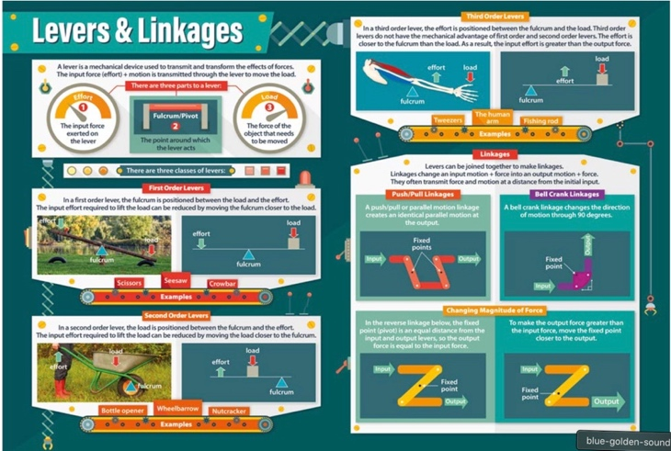

Why Time- Sound / Levers and Linkages

Week beginning 23rd November 2020

Topic / D&T

Watch: <https://www.bbc.co.uk/bitesize/clips/zrp6n39>

Make a list of what uses linkages in your home.

RE

* Have a look at these designs: <https://www.pinterest.co.uk/donnateve63/stained-glass-bible-stories/>
* Choose a parable from the bible then create a stained glass design that reflects the story.

Science

<https://www.bbc.co.uk/bitesize/clips/zswsbk7>

* Refresh your knowledge on sound by using the link above.
* If you can make your own tin can telephone.
* Write up a report explaining how it works.